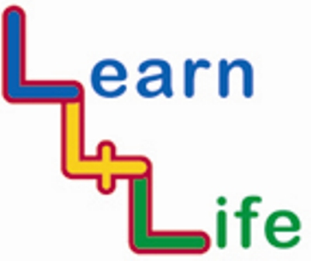
PSHE Education Learning Map

QCA End of Key Stage Statements (KS1) | Learning Opportunities
PERSONAL DEVELOPMENT | Curricular |  | Extra-Curricular
Pupils can: | Discrete PSHE/Citizenship | Cross-Curricular Links | Clubs and Activities | Assembly | School Council | Residential visits | Community Links | Charities and Projects
Identify and name some feelings and express some of their positive qualities

Demonstrate that they can manage some feelings in a positive and effective way

Begin to share their views and opinions

Set themselves simple goals

QCA End of Key Stage Statements (KS1) | Learning Opportunities
HEALTHY LIFESTYLE | Curricular |  | Extra-Curricular
Pupils can: | Discrete PSHE/Citizenship | Cross-Curricular Links | Clubs and Activities | Assembly | School Council | Residential visits | Community Links | Charities and Projects
Make simple choices about some aspects of their health and well-being, and know what keeps them healthy
Explain ways of keeping clean

Name the main parts of the body

Talk about the harmful aspects of some household products

Describe ways of keeping safe in familiar situations

Explain that people grow from young to old

QCA End of Key Stage Statements (KS1) | Learning Opportunities
RELATIONSHIPS | Curricular |  | Extra-Curricular
Pupils can: | Discrete PSHE/Citizenship | Cross-Curricular Links | Clubs and Activities | Assembly | School Council | Residential visits | Community Links | Charities and Projects
Recognise that bullying is wrong and list some ways to get help in dealing with it

Recognise the effect of their behaviour on other people, and cooperate with others

Identify and respect the differences and similarities between people

Explain different ways that family and friends should care for one another

QCA End of Key Stage Statements (KS2) | Learning Opportunities
PERSONAL DEVELOPMENT | Curricular |  | Extra-Curricular
Pupils can: | Discrete PSHE/Citizenship | Cross-Curricular Links | Clubs and Activities | Assembly | School Council | Residential visits | Community Links | Charities and Projects
Demonstrate that they recognise their own worth and that of others

Express their views confidently and listen to and show respect for the views of others

Identify positive ways to face new challenges

Discuss bodily and emotional changes and demonstrate ways of dealing with these positively
Talk about a range of jobs, and explain how they will develop skills to work in the future

Demonstrate how to look after and save money

QCA End of Key Stage Statements (KS2) | Learning Opportunities
HEALTHY LIFESTYLE | Curricular |  | Extra-Curricular
Pupils can: | Discrete PSHE/Citizenship | Cross-Curricular Links | Clubs and Activities | Assembly | School Council | Residential visits | Community Links | Charities and Projects
Make choices about how to develop healthy lifestyles

Identify some factors that affect emotional health and well-being

Make judgements and decisions and list some ways of resisting negative peer pressure around health and well-being

List commonly available substances and drugs that are legal and illegal, and describe some of the effects and risks of these

Identify and explain how to manage the risks in different familiar situations

QCA End of Key Stage Statements (KS2) | Learning Opportunities
RELATIONSHIPS | Curricular |  | Extra-Curricular
Pupils can: | Discrete PSHE/Citizenship | Cross-Curricular Links | Clubs and Activities | Assembly | School Council | Residential visits | Community Links | Charities and Projects
Explain how their actions have consequences for themselves and others

Describe the nature and consequences of bullying, and express ways of responding to it

Identify different types of relationships and show ways to maintain good relationships

Respond to, or challenge, negative behaviours such as stereotyping and aggression

Describe some of the different beliefs and values in society, and demonstrate respect and tolerance to people different from themselves

